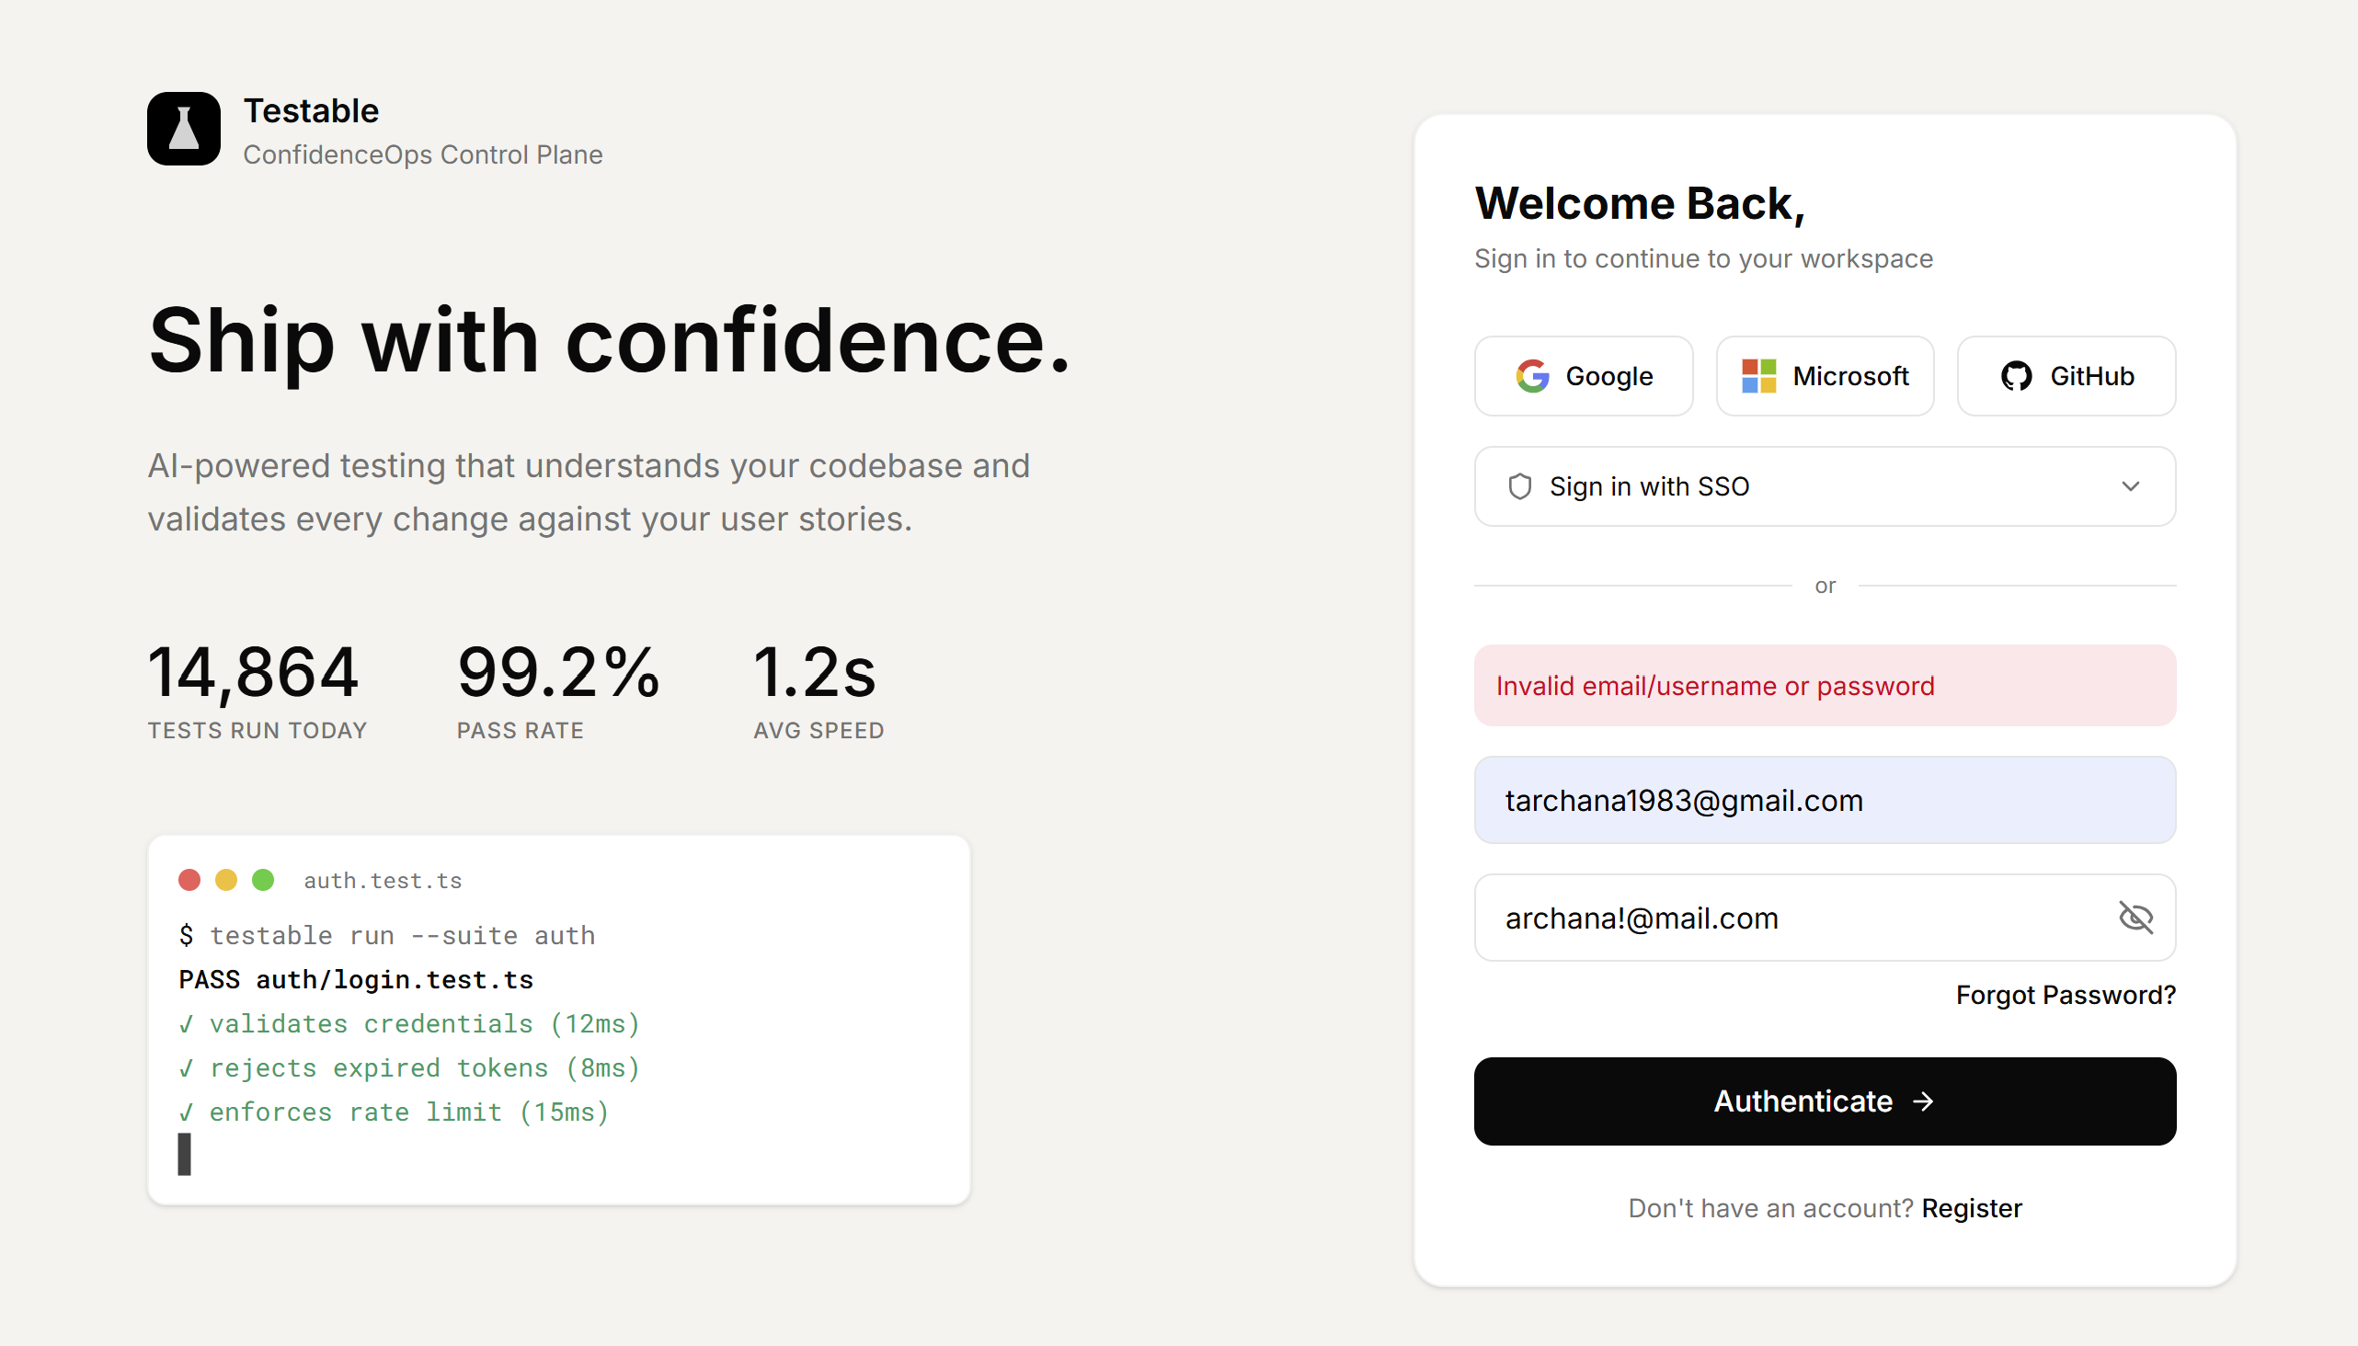
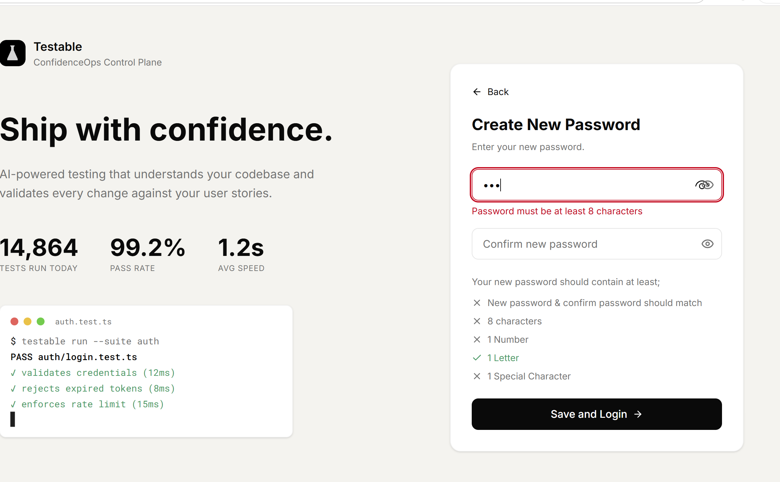
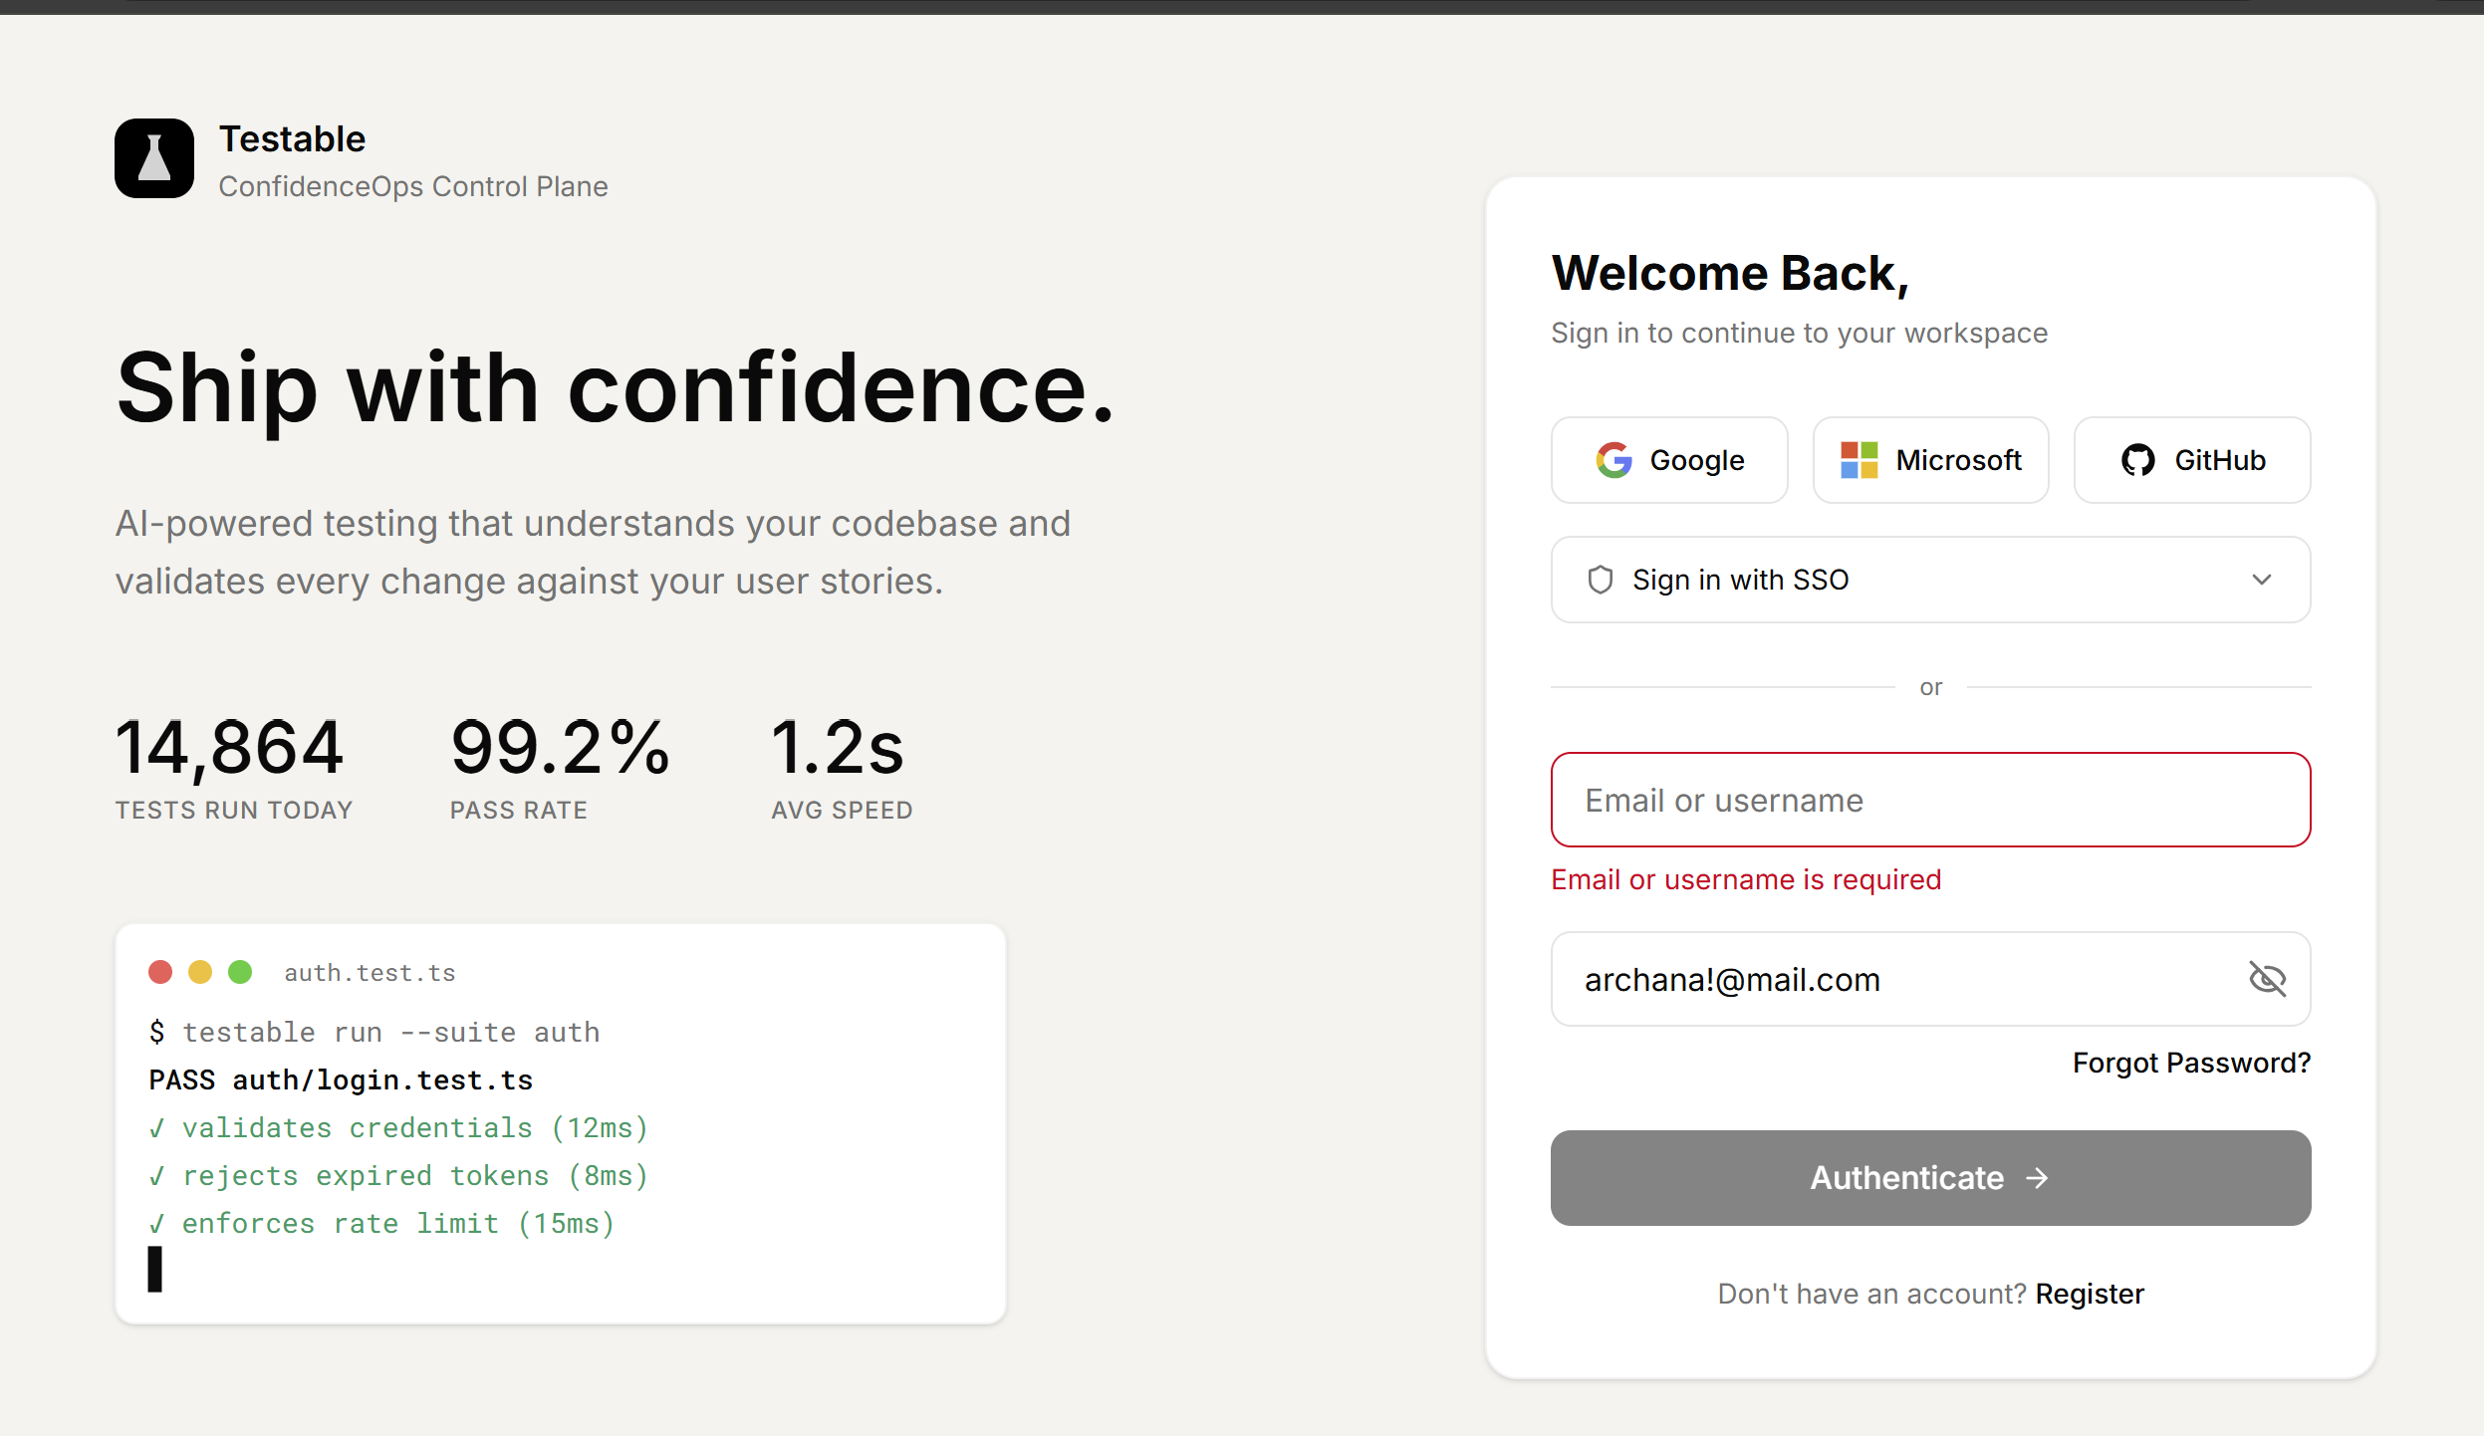

Observation1: TC_Login_with _Special_characters_in_credentials
As per the US Special characters except @, ., _, and - shall not be allowed in email
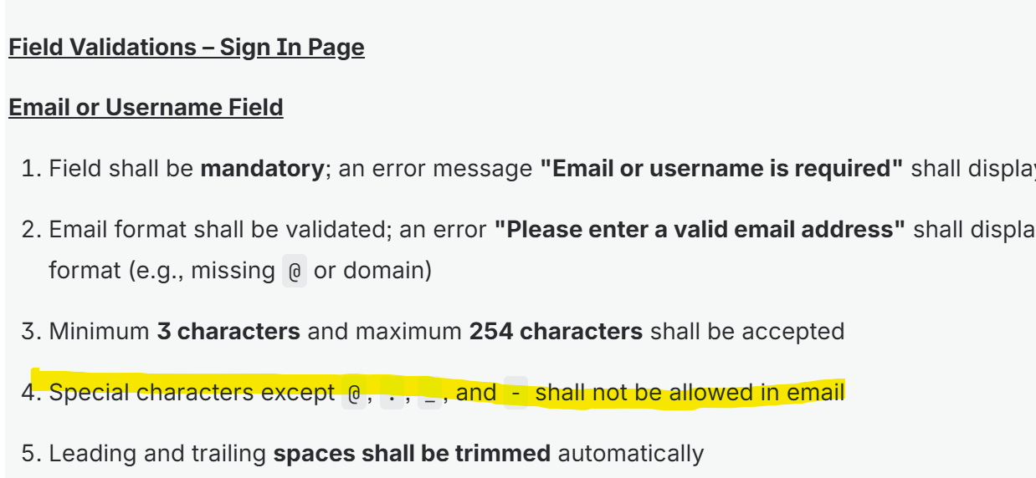
Expected Result: Special character + should not be allowed in the email and should through error message” Please enter a valid email address”
Actual Result: Special character + were allowed in the email and error message not displayed
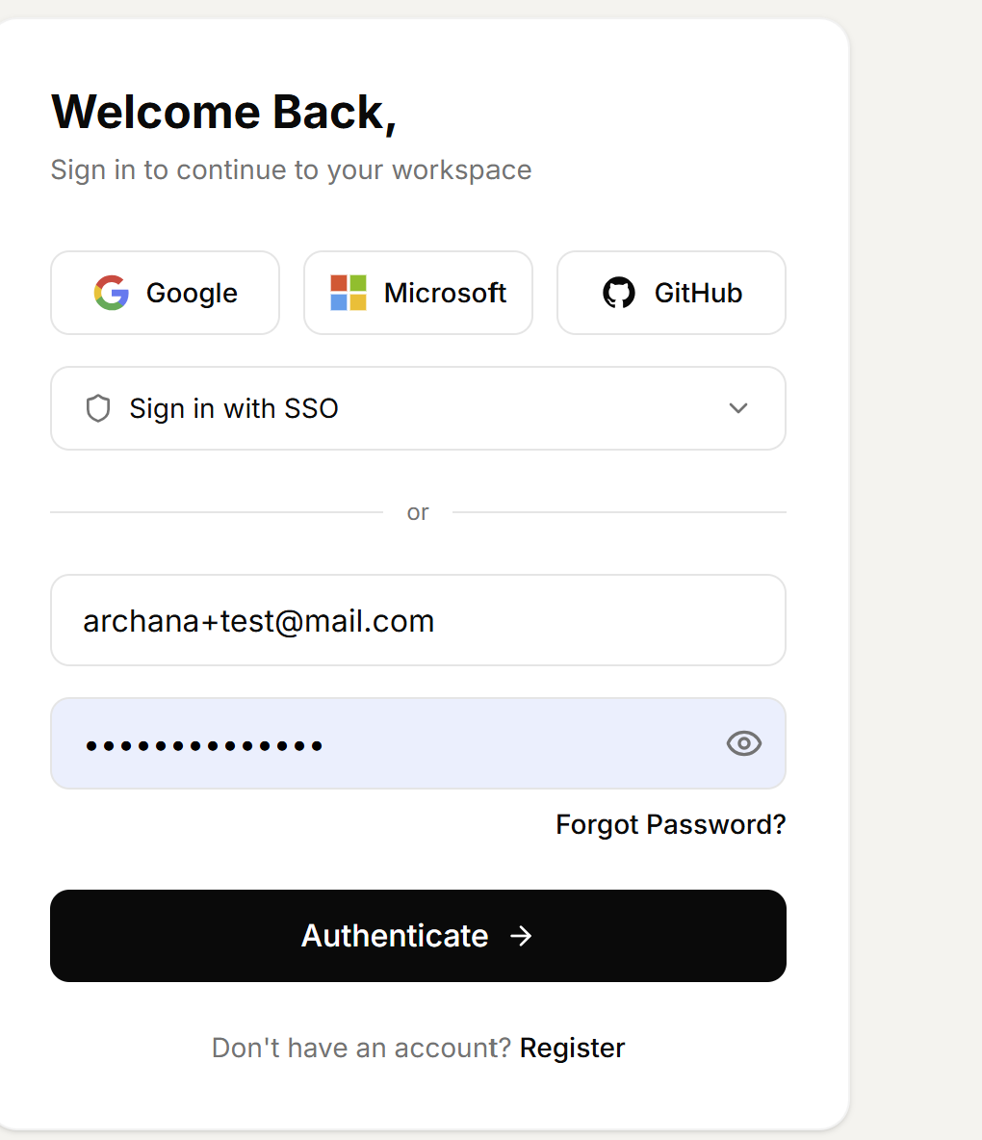

Observation1:
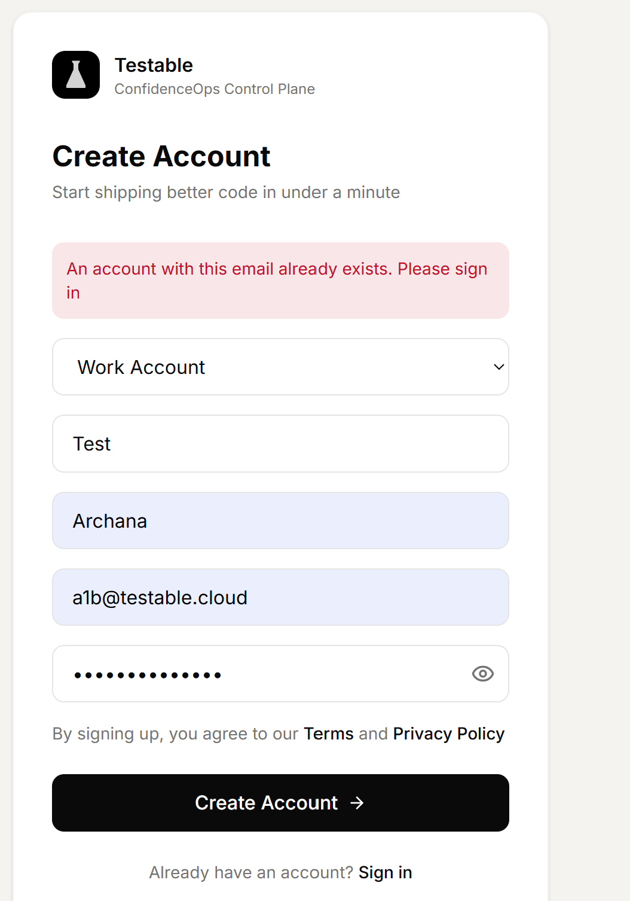

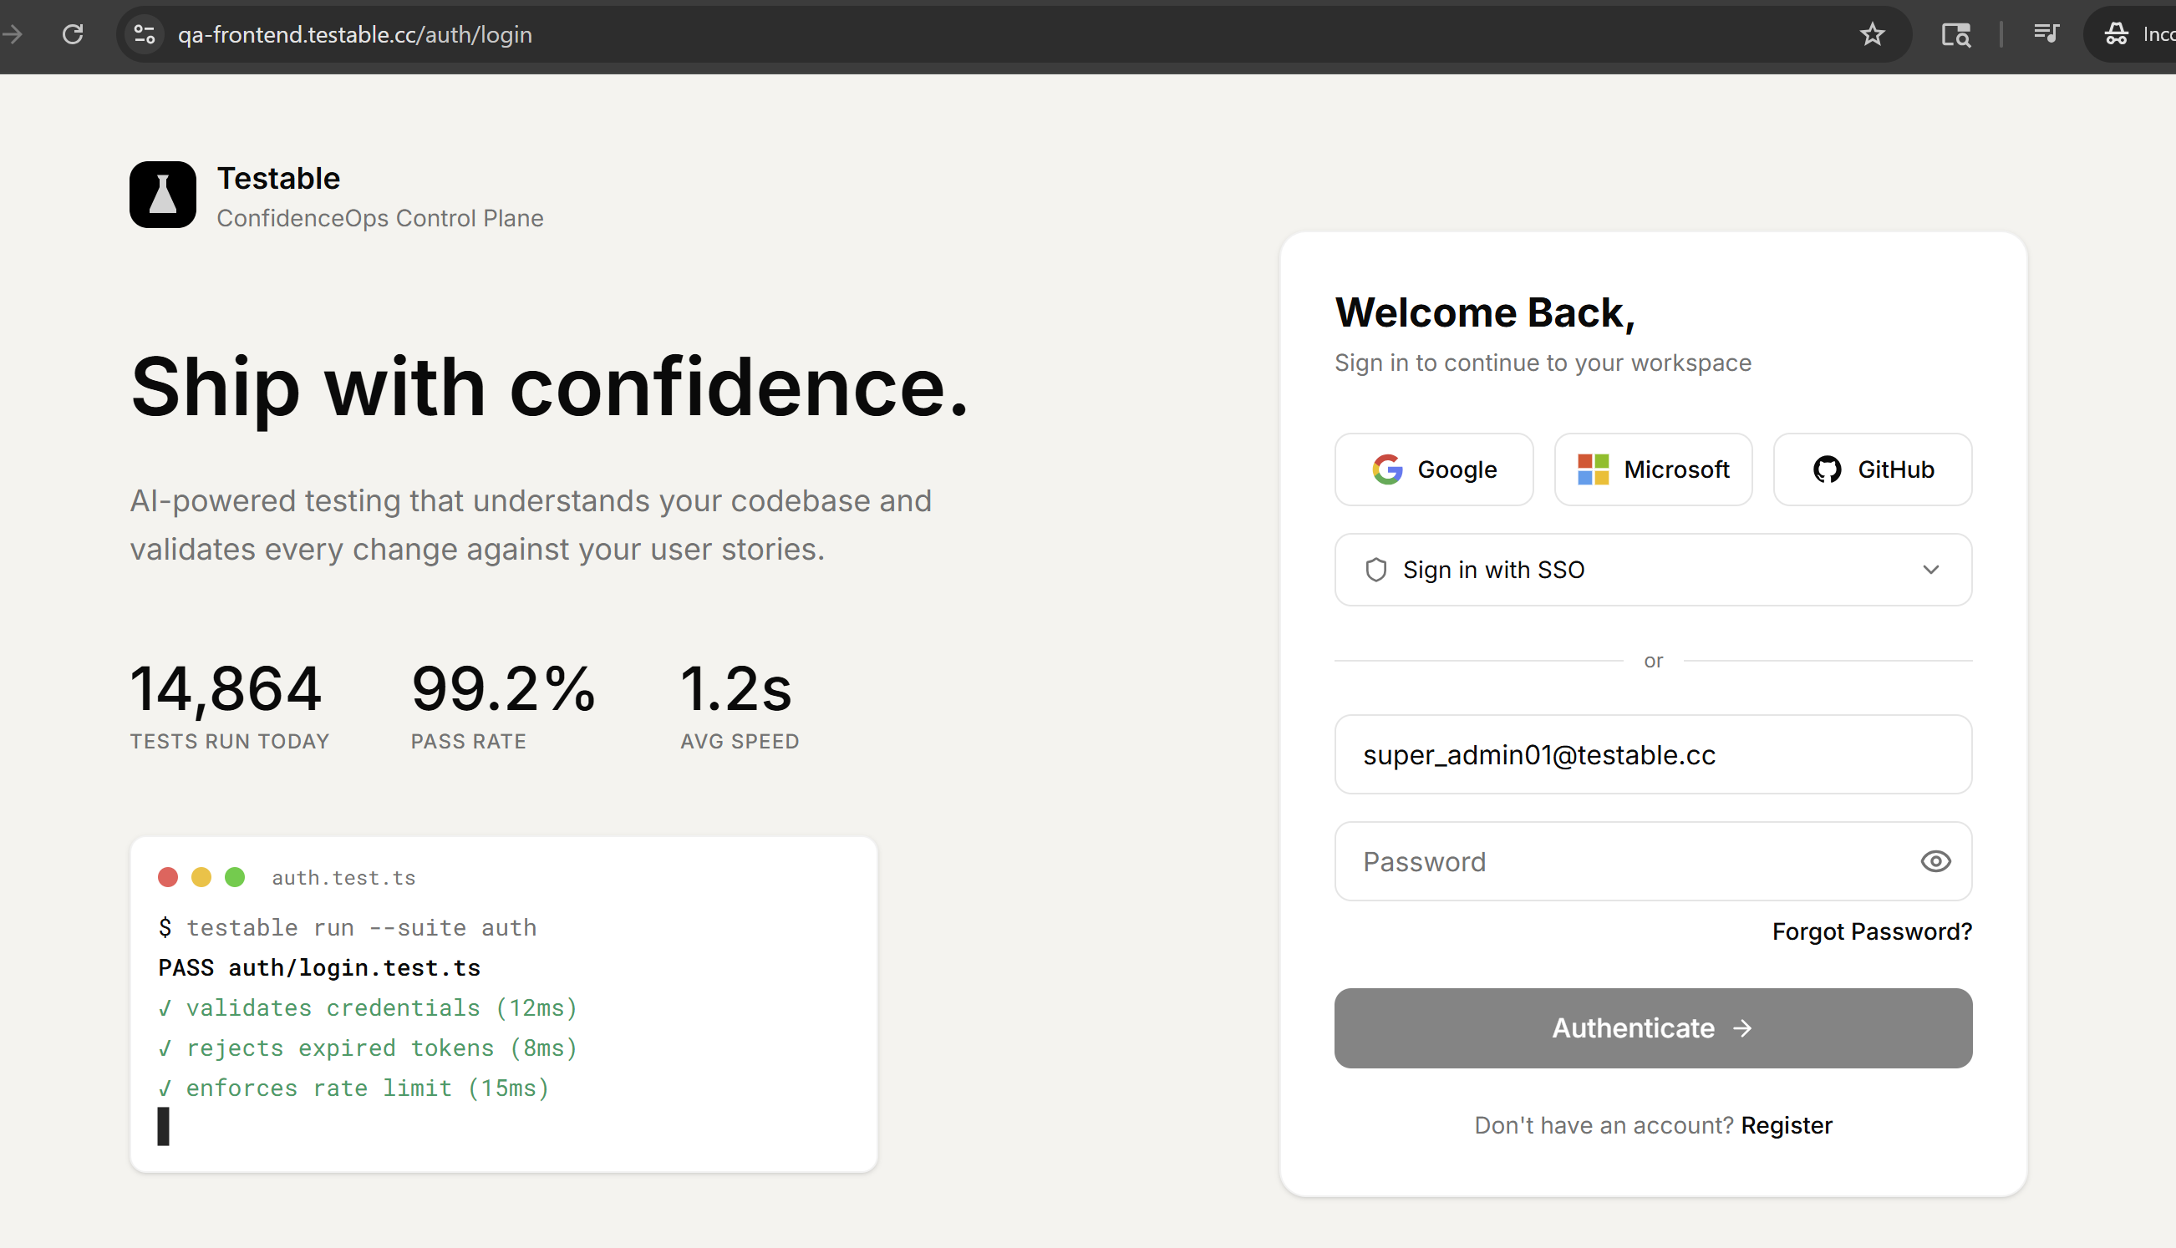
created >= -30d order by created DESC

